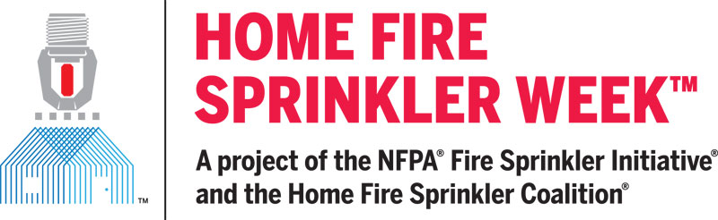

For immediate release

Contact: Peg Paul, Communications Manager
Home Fire Sprinkler Coalition
815-592-9278
peg@ppacom.com

FIRE DEPARTMENTS ARE JOINING WITH NFPA FIRE SPRINKLER INITIATIVE AND HOME FIRE SPRINKLER COALITION THIS MAY IN A FAR-REACHING EFFORT TO IMPROVE HOME FIRE SAFETY

Virtual Reality fire footage, videos, and other resources at MEDIA ROOM

QUINCY, MA April 22, 2022 – In every community, home fires are a severe threat to residents as well as responding firefighters. While homes have been the central fire challenge for decades, today this problem is intensified by the fact that unprotected home fires become deadly in just two minutes or less. To confront this stubborn public safety burden, fire departments and safety advocates across North America will team up May 15-21 for Home Fire Sprinkler Week.

In its fifth year, the Week is co-hosted by the Fire Sprinkler Initiative project of the National Fire Protection Association (NFPA) and the Home Fire Sprinkler Coalition (HFSC). The event focuses on the home fire problem and the need for better understanding of the life safety benefits of installed home fire sprinklers. The free, online digital messaging and local outreach activities will help departments of any size and type achieve their community risk reduction goals through local education and outreach.
According to NFPA, more than three-quarters of all civilian fire deaths occur in home fires. The vast majority of these fatal fires are preventable and their causes are largely the same as they have been for many years. Fire safety advocates work hard to educate about home fire dangers, but every fire cannot be prevented.
“When things go wrong and a fire starts, home fire sprinklers work automatically and very effectively,” says Lorraine Carli, NFPA vice president of Outreach and Advocacy and president of the HFSC. “Mistakes happen, but the real transgression is that approximately one million new homes will be built this year and only a fraction of them will be protected with the proven technology that would prevent injuries, save lives and protect property.”

Contributing to this is the common fallacy that new homes don’t burn. “They certainly do,” Carli says. Today, new homes are most commonly built with unprotected lightweight wood construction, and designed with large, open spaces. Homes are filled with synthetic furnishings that burn hotter and faster than natural materials producing toxic smoke. Regardless of age, home fires now burn faster than ever and become deadly so quickly.

“The simple answer is to install fire sprinklers in new home construction,” Carli explains. “What thwarts progress are lacking public awareness, rampant myths and the influence of special interests.” This year’s Home Fire Sprinkler Week responds with a range of powerful educational tools to address those, including an exciting new virtual reality resource that helps stakeholders, homebuilders, and consumers see and believe how important fire sprinkler protection is.

HFSC’s virtual reality (VR) videos were created from actual home fire flashover and fire sprinkler activation footage. Unlike animated VR films, the footage was shot live as the fires burned. The result is memorable. With user-controlled 360-degree, full-room views, viewers experience the fires as if they were actually in the room, seeing the fires and sprinkler activation from any angle. The VR videos can be watched with 3D glasses or headsets for an immersive experience as well as in 2D on HFSC’s website.
A dedicated Home Fire Sprinkler Week Website also includes other videos, animations, graphic art and messaging that corresponds to daily themes. All the resources are free and can be selected at will and customized. With a couple of clicks, the turnkey resources can go viral on social media and websites, helping any fire department educate about home fire dangers and the unparalleled protection of installed home fire sprinklers.

Fire safety advocates know, and every year national fire data reinforces, installed fire sprinklers reduce home fire injuries, deaths and property loss. “That’s why all national building codes require sprinklers in new construction,” Carli says. “As a result, every new home built without fire sprinklers is by definition substandard. Today’s homebuyers are savvy about safety and when they learn about fire sprinklers, they want them. The virtual reality, digital and other Home Fire Sprinkler Week resources underscore not just that we can do better; they underscore exactly how to do better.”
For free resources and media information visit Home Fire Sprinkler Week Media Resources

# # #

About the Home Fire Sprinkler Coalition (HFSC)
HFSC was formed in 1996 to inform the public about the life-saving value of sprinkler protection in one- and two-family homes. HFSC is a purely educational, nonprofit organization and the leading resource for independent, noncommercial information about home fire sprinklers. For more information about HFSC and home fire sprinklers, visit www.homefiresprinkler.org.
Contact Peg Paul: 815-592-9278

NFPA®: 125 Years of Protecting People and Property
The National Fire Protection Association® (NFPA®) is a global self-funded nonprofit organization devoted to eliminating death, injury, property, and economic loss due to fire, electrical, and related hazards. The association began its work to solve the fire problem in a young, industrialized nation in 1896 and is recognized around the globe as a leader in advocating for safety. NFPA delivers information and knowledge through more than 325 consensus codes and standards, research, training, education, outreach, and advocacy; and by partnering with others who share an interest in furthering the NFPA mission. In celebration of its 125th Anniversary, NFPA will be hosting a Conference Series and other initiatives that reflect the steadfast commitment to advancing fire and life safety by the association for the next 125 years and beyond. For more information or to view NFPA codes and standards for free, visit www.nfpa.org.
Contact: Lorraine Carli, Public Affairs Office: +1 617-984-7275

