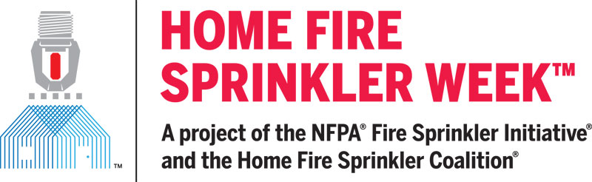

For immediate release

Contact: Peg Paul, Communications Manager
Home Fire Sprinkler Coalition
815-592-9278
peg@ppacom.com

FIRE DEPARTMENTS AND SAFETY ADVOCATES ENCOURAGED TO PARTICIPATE IN HOME FIRE SPRINKLER WEEK DIGITAL CAMPAIGN

QUINCY, MA April 25, 2023 – In every community, home fires are a severe threat to residents as well as responding firefighters. Homes account for 97 percent of residential structure fires and 75 percent of all civilian fire deaths. Today this problem is intensified by the fact that homes with modern furnishings, open spaces and unprotected lightweight wood construction make home fires deadly in two minutes or less. To confront this stubborn public safety burden, fire departments and safety advocates across North America will team up May 14-20 for Home Fire Sprinkler Week. Together, they will amplify the message that fire sprinklers stop a fire from becoming deadly, protecting residents and firefighters.

The Home Fire Sprinkler Coalition (HFSC) digital campaign focuses on the home fire problem and the need for better understanding of the life safety benefits of installed home fire sprinklers. Every day there is a different theme and content for social media and websites that focus on key facts about home fire sprinklers. The messages are sized for various social media, so it is easy to share with little time and effort. Everyone is encouraged to visit the website every day during the week and share the messages
“Educating and increasing awareness about home fire sprinklers can be a challenge,” said Lorraine Carli, NFPA vice president of Outreach and Advocacy and president of the HFSC. “What thwarts progress is lacking public awareness, rampant myths and the influence of special interests. More than 1 million homes are built each year, and less than 10% are protected with fire sprinklers. Homes without fire sprinklers counters the goals of community risk reduction. During Home Fire Sprinkler Week, we work together to increase awareness,” Carli said.

This year’s Home Fire Sprinkler Week responds with a range of powerful educational tools including HFSC’s virtual reality resource that helps viewers see and believe how fast fire becomes deadly and how important fire sprinkler protection is. These VR videos were created from actual home fire flashover and fire sprinkler activation footage. The footage was shot live as the fires burned. The result is memorable. With user-controlled 360-degree, full-room views, viewers experience the fires as if they were actually in the room, seeing the fires and sprinkler activation from any angle. The VR videos can be watched with 3D glasses or headsets for an immersive experience as well as in 2D on HFSC’s website.
Fire safety advocates know, and every year national fire data reinforces, installed fire sprinklers reduce home fire injuries, deaths and property loss. “That’s why all national building codes require sprinklers in new construction,” Carli says. “As a result, every new home built without fire sprinklers is by definition substandard. Today’s homebuyers are savvy about safety and when they learn about fire sprinklers, they want them. The virtual reality, digital and other Home Fire Sprinkler Week resources underscore not just that we can do better; they underscore exactly how to do better.”
For free resources and media information visit Home Fire Sprinkler Week Media Resources

# # #

About the Home Fire Sprinkler Coalition (HFSC)
HFSC was formed in 1996 to inform the public about the life-saving value of sprinkler protection in one- and two-family homes. HFSC is a purely educational, nonprofit organization and the leading resource for independent, noncommercial information about home fire sprinklers. For more information about HFSC and home fire sprinklers, visit www.homefiresprinkler.org.

Contact Peg Paul: 815-592-9278

