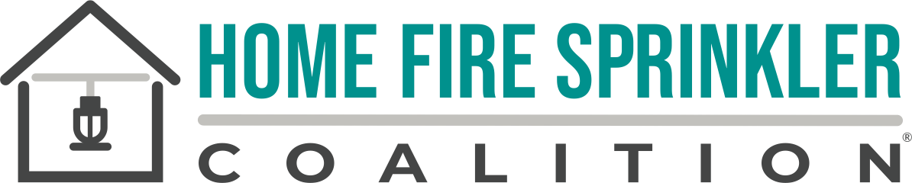

HFSC Fact Sheet

Formed in 1996, HFSC is a 501(c)(3) charitable organization and the leading resource for independent, noncommercial information about home fire sprinklers, their installation and operation, and their proven protection of people, pets and property. HFSC strives to improve and increase awareness of home fire dangers and the life safety benefits of sprinklers for residents and responding firefighters. HFSC creates original and effective educational content and advocacy resources and offers them at no cost. HFSC’s BUILT FOR LIFE® Fire Department program (BFLFD) is a free resource that supports fire service public sprinkler education as a method to achieve local Community Risk Reduction (CRR) goals. More than 3,800 BFLFD members routinely demonstrate how access to the right information and tools drives effective home fire sprinkler education.

Home Fire Risk in One- and Two-Family Homes
According to the National Fire Protection Association (NFPA) Fire Loss in the United States report, while the frequency of home fires has decreased since 1980 by 56%, the death rate has increased by 44%. Fires in one- and two-family homes have caused:
- 1 death in every 100 fires
- 2,580 civilian fire deaths (86% of all residential structure fire deaths)
- 6,630 injuries.
- $8.7 billion in direct property damage

Today’s home fires are much different than they were 40 years ago. A home fire can become deadly in as little as two minutes. Modern home contents such as synthetic furniture, polyurethane foam, plastics, and other engineered materials burn very fast and produce highly toxic, quickly spreading smoke compared with the natural-fiber and wood-heavy furnishings common decades ago. Today’s widespread reliance on lithium‑ion batteries and electronics creates fast‑growing home fires.

Home Fire Mitigation
Fire sprinklers are the only technology that can stop a fire from becoming deadly. They have been protecting a wide range of structures for more than a century, but their use has been slow to catch on in homes with less than 10% of all new homes protected. Broader installation of home fire sprinklers would save thousands of lives (USFA). Installing home fire sprinklers uniquely protects residents, property and the firefighters who respond to fires in these structures.

Home Fire Activation
If a fire occurs, the sprinkler closest to it activates automatically, in response to the high heat from a fire. This controls (and often extinguishes) the flames, reduces the spread of toxic and damaging smoke, and provides time for occupants to escape. When sprinklers are present, fire is kept to the room of origin 96% of the time (NFPA). In most home fires, only one or two sprinklers will control the blaze. In fires in unsprinklered homes, the toxic smoke spreads widely and more area is exposed to heat, smoke and fire. This requires more water to be used for suppression with powerful fire department hoses. This greatly increases water and fire damages to the structure and contents.

First Responders
Installing home fire sprinklers helps communities in many ways, including protecting first responders from fire and exposure hazards. Today’s home fires are dangerous for firefighters as well as occupants. Firefighters are 11 times more likely to be injured fighting structure fires; 87% of their injuries occur there (USFA 2019). The risk is not limited to fire exposure. Firefighters today face a 9% higher rate of cancer diagnoses and a 14% higher rate of cancer-related deaths compared to the general population in the U.S. (FirefighterCancerSupport.org)

Environment
Home fire sprinklers also protect property and the environment. In 2021, FM reaffirmed the 2010 Environmental Impact of Residential Fires Review that proved the environmental benefits of fire sprinklers:

- Greenhouse gas emissions were cut by 97.8%
- Water usage was reduced between 50% and 91%
- Fewer persistent pollutants, such as heavy metals, were found in sprinkler wastewater versus fire hose water
- The high pH level and pollutant load of non-sprinkler wastewater are an environmental concern

Homebuyers
Today’s homebuyers want smarter homes. In a recent national fire safety survey* of more than 2,000 adults of all ages, 86% said fire safety was important as they look to buy a new home. After learning how home fire sprinklers work, 80 percent of millennials, the largest age group buying homes, said they would prefer to buy a home with fire sprinklers.

*HFSC Omnibus survey with Opinium, surveying a nationally representative sample of more than 2,000 US adults.

NFPA Reports:
Fire loss in the United States, Shelby Hall, October 2025. https://www.nfpa.org/education-and-research/research/nfpa-research/fire-statistical-reports/fire-loss-in-the-united-states

