Proclamation

WHEREAS, the effects of home fires are far-reaching and long-lasting. A house fire can become deadly in as little as two minutes because of common synthetic furnishings that burn quickly and produce toxic smoke, lightweight construction material and open plans used in today’s construction, and emerging technologies such as lithium-ion batteries; and

WHEREAS, homes should be the place where residents feel safest. In reality, the home is where people face the greatest risk of injury or death from fire; and

WHEREAS, home fires put our firefighters at risk through exposure that can lead to long-term health issues; and

WHEREAS, when combined with working smoke alarms and proper fire escape planning, fire sprinklers in all new homes can reduce the devastating effects of home fires, and

WHEREAS, by taking part in Home Fire Sprinkler Week, we recognize that protecting new homes with fire sprinklers will make the future safer for residents, first
responders, and entire communities for generations to come.

NOW, THEREFORE I, __________________________________________________________________________________________ , by virtue of the authority vested in me, do hereby proclaim:

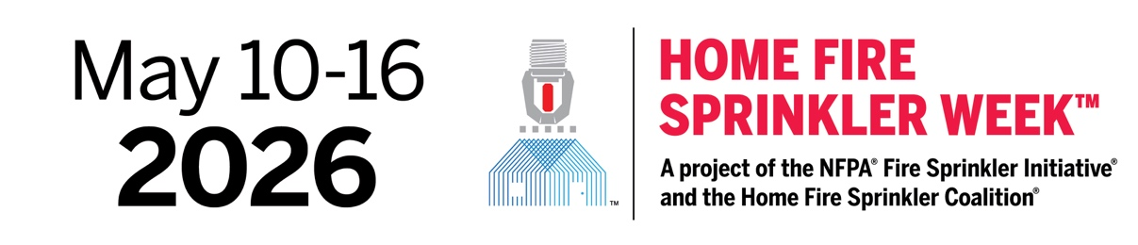

I encourage all residents to educate themselves about the dangers of home fires and the
unparalleled benefits of home fire sprinklers and to embrace this technology in all
of our city’s new homes.

