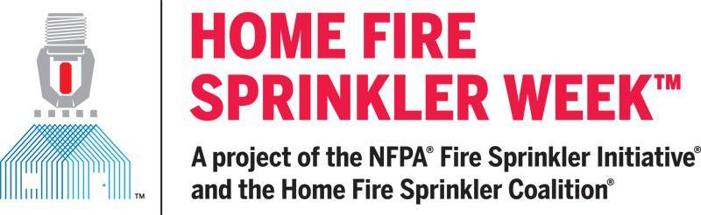

For immediate release

Contact: Peg Paul, Communications Manager
Home Fire Sprinkler Coalition
815-592-9278
peg@ppacom.com

NATIONAL CAMPAIGN TO INCREASE AWARENESS ABOUT WHY HOME FIRES ARE FASTER - AND WHY HOME FIRE SPRINKLERS ARE THE ONLY TECHNOLOGY THAT CAN STOP A FIRE FROM BECOMING DEADLY
QUINCY, MA, APRIL 8, 2026 – Home Fire Sprinkler Week is scheduled for May 10-16, 2026. Fire departments and safety advocates across North America will deliver powerful messages about why home fires can become deadly in less than two minutes and how fire sprinklers protect residents and firefighters from death and injury while dramatically reducing property loss.
Home fires are much different than they were 40 years ago. Modern home contents such as synthetic furniture, polyurethane foam, plastics and other engineered materials burn very fast and produce highly toxic, quickly spreading smoke compared with the natural-fiber and wood-heavy furnishings common decades ago. Widespread reliance on lithium‑ion batteries and electronics creates fast‑growing home fires. A house fire can become deadly in as little as two minutes, drastically reducing the window for detection and evacuation.
Fire sprinklers are the only technology that can automatically stop a fire from becoming deadly. Each sprinkler is individually activated by heat from a fire, so only the sprinkler closest to the fire activates, putting water on the fire when it is small, stopping it from spreading and producing toxic smoke, allowing people to safely escape. Fire sprinklers use far less water compared to firefighter hoses and have significantly reduced environmental impact.
Throughout the week, fire departments will participate in the Home Fire Sprinkler Coalition (HFSC) digital campaign, and share daily messages about fire sprinklers through social media.
Many fire departments will also offer community outreach events with dramatic live fire demonstrations and displays.
The daily themes are:
- Monday - Fires Are Fast, Sprinklers Are Faster
- Tuesday - The Cost to Communities Without Fire Sprinklers
- Wednesday - Fire Sprinklers Are Part of a Fire-Safe Community
- Thursday - It’s Easy to Live with Home Fire Sprinklers
- Friday - Protect What You Value Most
There are extensive resources at the HFSC Studio to help participants create materials for community outreach. With this easy-to-use online tool, departments can design their own flyers, posters, and social media cards; share messages on social media; produce videos; issue a customized proclamation; and produce educational materials.
“Home Fire Sprinkler Week is a great opportunity for us to bring together our digital voices and amplify the message of the tremendous benefits of fire sprinklers across our continent,” said Lorraine Carli, NFPA vice president of Outreach and Advocacy and president of the HFSC.
“Today’s homebuyers are savvy about safety and when they learn about fire sprinklers, they want them. The virtual reality, digital and other resources underscore not just that we can do better, they underscore exactly how to do better.”
For free resources and media information, visit Home Fire Sprinkler Week Media Resources

# # #

About the Home Fire Sprinkler Coalition (HFSC)
HFSC was formed in 1996 to inform the public about the life-saving value of sprinkler protection in one- and two-family homes. HFSC is a purely educational, nonprofit organization and the leading resource for independent, noncommercial information about home fire sprinklers. For more information about HFSC and home fire sprinklers, visit www.homefiresprinkler.org.
Contact Peg Paul: 815-592-9278

